Contact:  Don Elias  don@christianvalley.org |  | Christian Valley Park, CSD Newsletter | October 2022
Our Mission  CVPCSD shall provide the best possible services to those residing within the District boundaries and jurisdictions, which will include but are not limited to: provision of potable water, road maintenance and other road or safety improvements within the District’s boundaries, in the most efficient and economical way possible. This will be done by remaining a small, innovative governmental entity operating on sound principles in a safe, professional, and courteous manner and encouraging community participation in its decision making.  Proper Drainage is Essential  Residents should make sure that ditches and driveway culverts on their property are clear of debris or obstructions. With the rainy season coming, maintaining proper drainage can help reduce runoff on the roads and make our streets safer to drive on and also prolong the life of our roads. |  | 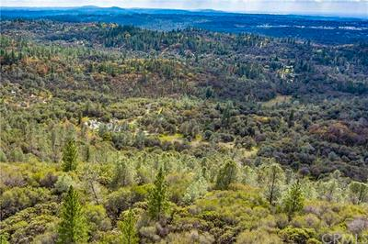  Want your photo featured? Email it to gipner@pm.me ~ CV from the air  New Water Plant Operations  After 22 years of professional and dependable service, Gerry LaBudde of Hydros Engineering Inc. is stepping down as the District’s primary water plant operator and engineer. We want to express our gratitude to Gerry and his team for their hard work and dedication to the District. Our new operator, Jason Hoffman of American River Backflow, has been chosen to ensure the continued smooth operation, maintenance, and timely emergency repair of our community’s water resource. With 15 years in the water business, American River Backflow is family-owned and based locally in Auburn. The District is confident that they will prove invaluable to our community for many years to come. Congratulations to American River Backflow and welcome to the Christian Valley family!  Maintaining Trees by Roadway  Keeping our roads clear of overhanging branches is essential for emergency vehicle access and good visibility for everyone. Residents are asked to trim trees on their property which border a road in order to allow a minimum of 2 feet clearance back from the edge of the road and a minimum of 14 feet in height.  New Administrative Assistant  Christian Valley Park, CSD is proud to introduce Scott Gipner, the newest member of our team. Scott lives on Barbara Lane with his wife and daughter and will serve as a second point of contact for the District.

