Christian Valley Park CSD – Pipeline Condition Assessment

Summary: CVPCSD provides treated water service to 627 customers within the district’s jurisdictions. The district purchases raw water from the Placer County Water Agency (PCWA) This CSD has an aging, mostly AC Pipe
The district has approximately 16 miles of mostly Asbestos Cement pipe and a varying amount 0f steel. Current CIP study provided by Hydros Engineering outlines maintenance and replacement needs for 1-5 years, 6-10 years. Within those years are major asset inventory, condition assessment of all assets, estimated useful life and cost of the pipe and facilities replacement with prioritized timeline.
Condition assessment of the pipelines will rely on two important factors.
- Available funds to perform the study – the CIP does not illustrate any funds to conduct survey. Grants from the state and financial aid from PCWA may be available.
- Access points for equipment to conduct study – need access to valve and hydrant spacing to determine if existing appurtenances will be sufficient to conduct study.
Pipeline replacement Costs:
Short Term 1-5 Years
- 2” steel Extension on Allen 350’ @34k
- 6” AC Witt Rd 2300’ @411k
- 8” steel Allen Replacement 2300’ @557k

          - Total $1,002,000
Long Term 6-10 Years
- 6”AC CVR Stanley to Mary 1400’ @304k
- 6”AC Stanley, Gayle – Virginia 3500’ @775k
- 10” AC Res to Greg 1400’ @345k
          - Total $1,402,000
Beyond 10 Years projection 13.5M
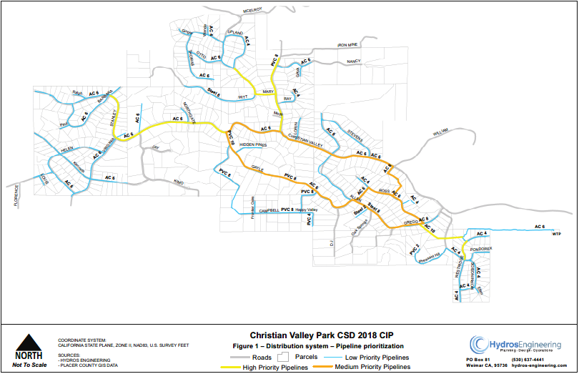

ePulse Condition Assessment Pricing for 16 miles (84,480’) of Pipeline 24” & under.

Item | Rate | Units | Est. Qty | Total
Site visit, one person
• First day | $5,050.00 | Lump Sum | 0 | $5,050.00
• Additional days | $2,250.00 | day | 0 | $0.00
ePulse testing
(Up to 24-inch diameter)
• First up to 1.5 miles | $45,210.00 | Lump Sum | 1 | $45,210.00
• Additional distance | $4.13 | ft | 76560 | $316,192.80
Remaining Service Life (RSL) | $0.86 | ft | 84480 | $72,652.80
Emergency mobilization (under 3 weeks' notice) | $5,000.00 | per trip | 0 | $0.00
Estimated Project Total |  |  |  | $439,105.60

ePulse Condition Assessment Pricing for 2 miles (10,560’) of Pipeline 24” & under.

Item | Rate | Units | Est. Qty | Total
Site visit, one person
• First day | $5,050.00 | Lump Sum | 0 | $5,050.00
• Additional days | $2,250.00 | day | 0 | $0.00
ePulse testing
(Up to 24-inch diameter)
• First up to 1.5 miles | $45,210.00 | Lump Sum | 1 | $45,210.00
• Additional distance | $4.13 | ft | 2640 | $10,903.20
Remaining Service Life
• Additional distance | $1.40 | ft | 10560 | $14,784.00
Emergency mobilization (under 3 weeks notice) | $5,000.00 | per trip | 0 | $0.00
Estimated Project Total |  |  |  | $75,947.20

